**Cryptoverse: A Cryptocurrency Dashboard**

**Table of Contents**

1. Acknowledgement
2. Synopsis
3. Introduction
4. Analysis of the Problem
   * System Analysis
   * Existing System
   * Limitations of Existing System
   * Proposed System
5. Feasibility Study
6. Analysis Tools
   * Functional Diagram
   * Dataflow Diagram
   * Entity Relationship Diagram
   * Hardware/Software Configuration
7. System Design
   * Input Design
   * Output Design
   * Software Specifications
8. Testing and Maintenance
9. Conclusion
10. Appendix
    * Screenshots
    * Tables
    * Codings
    * Reports
11. Bibliography

**Acknowledgement**

We would like to express our sincere gratitude to everyone who contributed to the development of this Cryptocurrency Dashboard project. Special thanks to the mentors, advisors, and the open-source community for providing valuable tools, libraries, and documentation to facilitate the development process.

We also acknowledge the resources provided by various APIs such as CoinGecko, CoinMarketCap, and others for providing real-time and historical cryptocurrency data.**Synopsis**

**The Cryptocurrency Dashboard provides a powerful tool for investors and crypto enthusiasts to monitor, analyze, and compare historical price data for various cryptocurrencies over the past five years. With this dashboard, users can examine detailed price trends, identify top-performing assets, and make informed investment decisions. The dashboard allows for customization of timeframes and offers an intuitive graphical interface to compare the price movements and volatility of different cryptocurrencies, facilitating informed market analysis and decision-making.**

**Introduction**

Cryptocurrency markets are highly volatile, making it crucial for investors to have a comprehensive understanding of price history to make informed decisions. The **Cryptocurrency Dashboard** is designed to empower users by offering a clear, visual representation of historical price data of cryptocurrencies over extended periods. The dashboard enables users to:

* Analyze historical price movements
* Compare multiple cryptocurrencies simultaneously
* Gain insights into market trends and patterns
* Make data-driven decisions to optimize cryptocurrency portfolios

This tool serves both as a valuable asset for investors and as an educational resource for anyone seeking to understand the evolving nature of cryptocurrency markets.

## Analysis of the Problem

### System Analysis

The main issue facing cryptocurrency investors is the overwhelming complexity of market data. Existing platforms often present raw data in tables or simple graphs, which can be difficult to interpret, especially when considering historical trends or making cross-asset comparisons. Investors need to quickly analyze long-term performance data to identify trends and make strategic decisions. There is also the challenge of aggregating data from multiple cryptocurrencies and ensuring that it is presented in an insightful and user-friendly format.

### Existing System

Current cryptocurrency dashboards or apps (such as CoinGecko, CoinMarketCap, and TradingView) provide historical data, but many of these platforms lack the level of customization or intuitive, dynamic analysis required by users. While they may offer price charts, they often do not allow for deeper analysis or comparison of various timeframes and assets.

### Limitations of Existing System

* **Limited Customization**: Users may not be able to customize the timeframes for analysis (e.g., by week, month, year).
* **Cluttered User Interface**: Some platforms are overloaded with information, making it difficult for users to focus on key data points.
* **Lack of Comparison Features**: Many dashboards lack the ability to compare multiple cryptocurrencies simultaneously.
* **No In-depth Analysis**: Existing platforms may not provide advanced analysis tools, such as volatility analysis, trend forecasting, or historical cycle recognition.

### Proposed System

The **Cryptocurrency Dashboard** will address the limitations of current systems by offering:

* **Customizable Timeframes**: Users can select specific date ranges for viewing historical price movements (e.g., 1 week, 1 month, 1 year, 5 years).
* **Multi-Asset Comparison**: Users can compare the price trends of multiple cryptocurrencies side by side.
* **Intuitive Visualization**: Data will be presented in user-friendly graphs and charts, enabling easy analysis.
* **Volatility & Risk Assessment Tools**: The dashboard will feature analytical tools that allow for volatility analysis and risk assessments, aiding decision-making.
* **Educational Insights**: The platform will provide historical trends and identify recurring patterns, helping users to understand cryptocurrency market cycles.

## Feasibility Study

### Technical Feasibility

The system is technically feasible using modern web technologies. The dashboard will be developed with React for the frontend, integrating with cryptocurrency data APIs (e.g., CoinGecko, CoinMarketCap) to retrieve historical price data. Data visualization will be done using libraries like Chart.js or D3.js. These technologies are well-documented, scalable, and capable of delivering the required functionality.

### Operational Feasibility

The dashboard will be deployed as a web application, accessible to users via their browsers. Given the increasing interest in cryptocurrencies and the need for detailed data analysis tools, the system will be highly beneficial to both novice and experienced investors. Regular updates and integration with real-time data sources will ensure that the system remains relevant.

### Economic Feasibility

The initial development of the system will require investment in tools, technologies, and API integrations. However, the system can be monetized by offering premium features such as advanced analytics, real-time alerts, and custom reports. Additionally, the system will integrate free APIs for basic functionality, ensuring cost-efficiency.

## Analysis Tools

### Functional Diagram

The **Functional Diagram** illustrates the key features of the Cryptocurrency Dashboard and their interactions with the system components, including data retrieval from cryptocurrency APIs, data visualization components, and user input.

Dataflow Diagram

**Dataflow Diagrams (DFD)** represent the flow of data within the system. The data will flow from external APIs to the backend, where it is processed and stored. The frontend will then retrieve this data and display it in a user-friendly format (graphs, charts, comparisons).

Entity Relationship Diagram

**Entity Relationship Diagram (ERD)** will show the relationships between data entities such as cryptocurrencies, historical price data, user profiles, and settings (customization preferences, timeframes).

### Hardware/Software Configuration

* **Frontend**: React.js, Chart.js/D3.js, Material-UI
* **Backend**: Node.js, Express (if custom backend required)
* **APIs**: CoinGecko API, CoinMarketCap API (for fetching cryptocurrency data)
* **Hosting**: AWS, Heroku, or Firebase for deployment

## System Design

### Input Design

Users will be able to input custom date ranges, select cryptocurrencies for comparison, and set preferences for the dashboard interface. The input forms will be simple and intuitive.

### Output Design

The output of the system will include interactive graphs and charts that display historical price data for selected cryptocurrencies. Users can toggle between different timeframes and view comparative data. Visual tools will include:

* Line charts for price trends
* Bar charts for volatility and performance comparisons
* Pie charts for market share of selected cryptocurrencies

### Software Specifications

* **Frontend**: React.js for the UI, using Chart.js for data visualization
* **Backend**: Node.js with Express for API handling (optional)
* **Data API**: CoinGecko API or CoinMarketCap API
* **Database**: Firebase or MongoDB (for storing user preferences and settings)

## Testing and Maintenance

### Testing

* **Unit Testing**: Testing individual components such as the cryptocurrency comparison tool and data fetching from APIs.
* **Integration Testing**: Ensuring that the frontend, backend (if applicable), and data APIs work seamlessly together.
* **User Acceptance Testing (UAT)**: Validating that the system meets the needs of the users and stakeholders.

### Maintenance

The dashboard will require regular updates to handle new cryptocurrencies, updates to APIs, and bug fixes. Maintenance tasks will also include data refreshes to ensure real-time accuracy and the addition of new features based on user feedback.

## Conclusion

The **Cryptocurrency Dashboard** is a powerful tool designed to empower cryptocurrency investors by providing comprehensive historical price data, detailed analysis tools, and user-friendly visualization. With the ability to compare multiple cryptocurrencies and customize the analysis, the platform will help users make data-driven decisions, track market trends, and identify patterns. This solution is well-suited for both novice and experienced crypto investors and offers a clear, intuitive interface for effective market analysis.

## Appendix

### Screenshots

1. **Dashboard Overview**: A screenshot showing the main dashboard with historical price charts and a comparison between multiple cryptocurrencies.
2. **Timeframe Selector**: A screenshot showing the interface where users can select the date range for analysis (1 week, 1 month, 1 year, 5 years).
3. **Cryptocurrency Comparison**: A screenshot displaying the comparison of two or more cryptocurrencies' price trends.

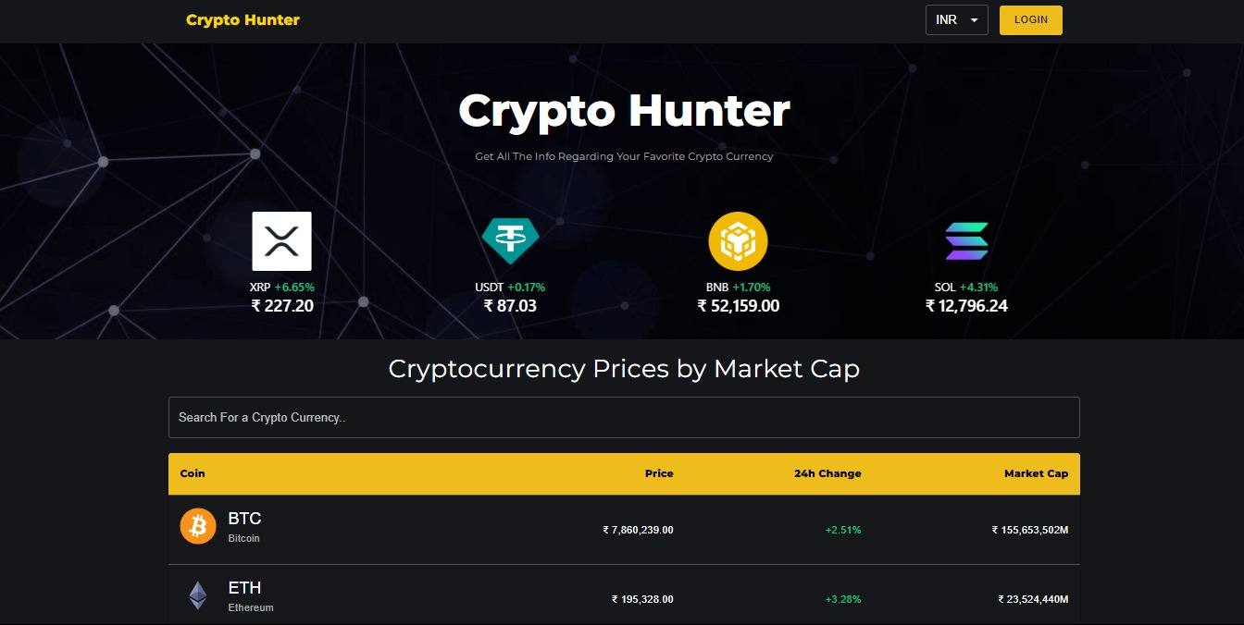

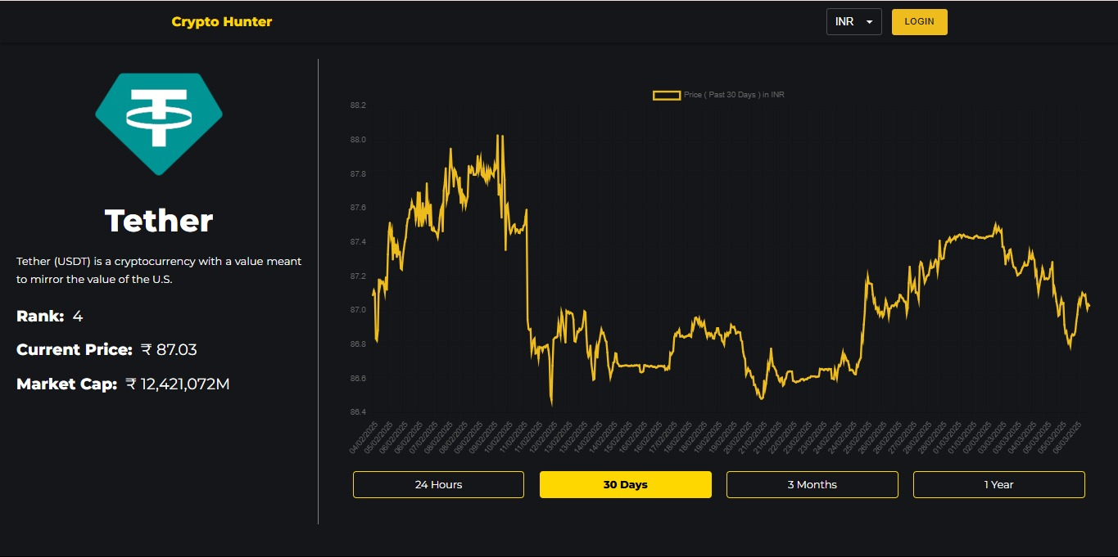



Tables

|  |  |
| --- | --- |
| Feature | Description |
| Custom Timeframes | |  | | --- | | Users can select date ranges for historical analysis (e.g., 1 week, 1 year). |  |  | | --- | |  | |
| Custom Timeframes | Allows users to compare price trends for multiple cryptocurrencies side by side. |
| Graphical Visualizations | Uses interactive charts and graphs (line, bar, pie) for data presentation. |

Reports

Reports detailing system performance, user feedback, and potential improvements will be documented in a comprehensive report for stakeholders.

**Bibliography**

1. CoinGecko API: https://www.coingecko.com/en/api
2. CoinMarketCap API: https://coinmarketcap.com/api/
3. React.js Documentation: https://reactjs.org/docs/getting-started.html
4. Chart.js Documentation: https://www.chartjs.org/docs/latest/